David Sharif POL 210 CRN 72614 Project #3, Nov. 17, New York: Pace University, Fall 2016
Presentation – Dominican Republic, Libya, Norway, Peru
Name, Attributes  Institutions | Extractive Performance | Symbolism | Regulation and Transparency | Distributive Performance | Political Recruitment
Dominican Republic  Caribbean nation, shares island of Hispaniola with Haiti between Caribbean Sea and North Atlantic ocean.  Capital – Santo Domingo  Climate - Tropical maritime, little temperature variation  Area 48,072 sq. km,  World rank 132  Pop. 10,606,685  world rank 88  Government: Presidential Multiparty  UN, UNESCO, WHO,WTO | $149.7 billion, rank 74  Highly dependent upon US, destination for approximately half of exports. Suffers from marked income inequality; poorest half of population receives less than one-fifth of GDP, while richest 10% enjoys nearly 40% of it.  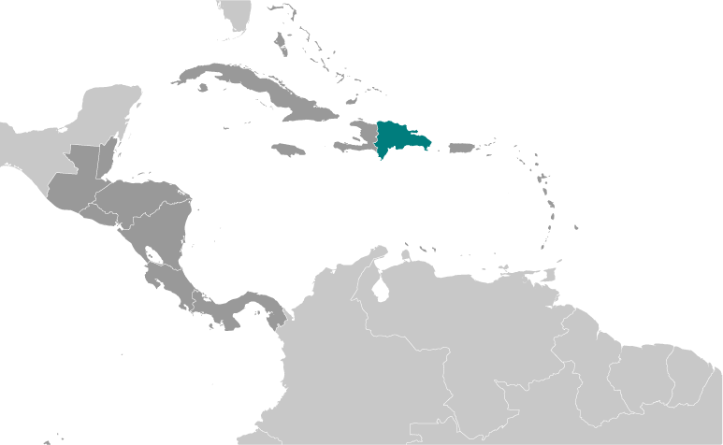 | 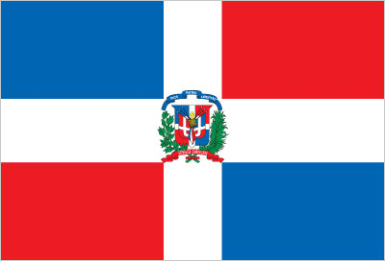  Palmchat (bird); national colors: red, white, blue.  Adopted 1934; also known as "Quisqueyanos valiants" (Valiant Sons of Quisqueye); anthem never refers to people as Dominican but rather calls them "Quisqueyanos,"  Displayed festively with pride as unifying symbol of Dominican identity at NYC parade annually. | Partly Free, Civil Liberties score 3  CPI Score 33/100  Control of Corruption 22%  Percentile  Human rights problems included extrajudicial killings by security forces; overcrowded and dangerously substandard prison conditions; arbitrary arrest; weak rule of law; impunity for corruption; chronic violence against women, including domestic violence, rape, and feminism. | $15,000 per capita  72.96 Expectancy years  Male 91.2%,  Female 92.3%  18.6 births/1,000/pop.  4.6 deaths/1,000/pop.  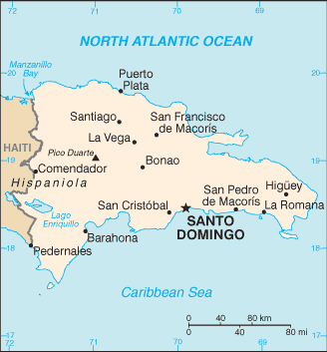  Coastal development is significant, especially in southern coastal plains, Cibao Valley, Population density is highest; smaller population clusters exist in interior mountains. | Political Rights 3  Civil law system is based on French Civil code; Criminal Procedures Code modified in 2004 to include important elements of accusatory system.  10 regions; (Yuma, Valdesia, Ozama, Higuamo, Enriquillo, El Valle, Cibao Sur, Cibao Norte, Cibao Noroeste, Cibao Nordeste)  95% Roman Catholic  Many active political parties freely participate in discussions. Ecnomoic oligarchies have influence over political choices
Libya  Northern Africa, borders Algeria, Tunisia, Egypt, Niger, Chad, Sudan and Med. Sea  Capital – Tripoli  Climate – Mostly desert oil-rich country  Area 1.77 Million sq. km, world rank 17  Pop. 6,541,948  world rank 107  Government: Presidential  Fractious parties  ICAO, IDB,  UN, UNESCO,  WMO, WTO | 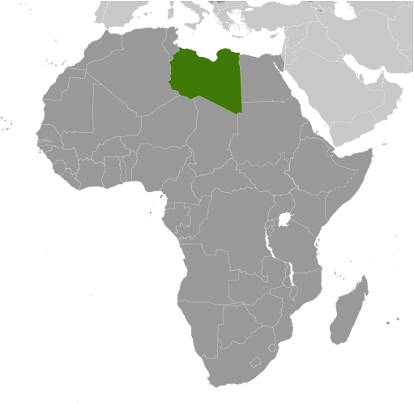$92.61 billion, rank 84  Affiliated with Islamic State of Iraq and Levant (ISIL) attacked Libyan oilfields in the first hall of 2015; has a presence in cities across Libya including near oil infrastructure, threatening future government renues from oil and gas. | Star and Crescent, hawk; national colors: red, black and green.  Also known as “Ya Beladi” adopted in 1951; readopted in 2011 with some modification during the QADHAFI years between 1969 and 2011, anthem was “Allahu Akbar.”  Libyans held flag during demonstrations boycotting French military intervention.  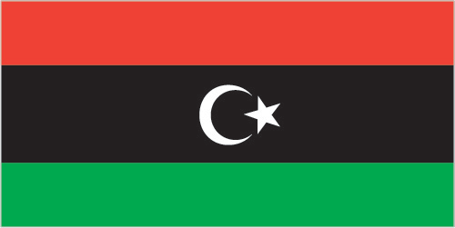 | Not Free, Civil Liberties  Score 6  CPI Score 16/100  Control of Corruption 6%  Percentile  Serious human rights problems resulted from absence of effective governance, justice, and security institutions. It abuses and violates committed groups affiliated with government, which are opponents, terrorists, and criminal groups. | $14,600 per capita  74.55 Expectancy years  Male 96.7%,  Female 85.6%  17.8 births/1,000/pop.  3.6 deaths/1,000/pop.  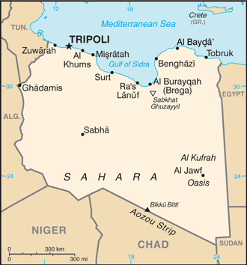  22 Districts  Independence in 1951 (from UN trusteeship).  Libya’s post-revolution legal system is in flux and driven by state and non-state entities. | Political Rights 6  More than hundreds of parties on political spectrum. Socialists to Islamists participate in GNC elections.  National Forces Alliance or NFA (includes many political organizations, NGOs and independents.  National Font (National Front for the Salvation of Libya, formed in 1981 as a diaspora opposition group)  Union for the Homeland  [Abd al-Rahman]  Justice and Construction Party or JCP [Mohamed SOWAN]
Norway  Northern Europe, borders Sweden, Finland, Russia, and the North Sea.  Capital – Oslo  Climate – Temperate along coast  Area 323,802 sq. km, world rank 68  Pop. 5,265,158  world rank 121  Government: Parliamentary Constitutional Monarchy  UN, ADB, AfDB, EITI, ICC | $356.2 billion, rank 49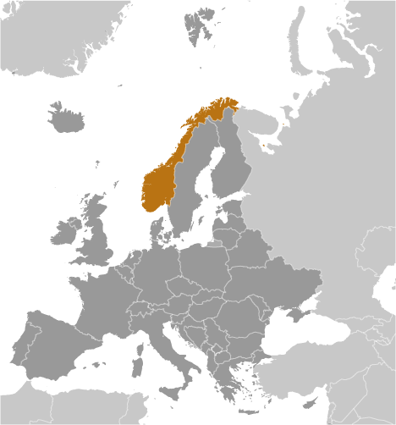  Richly endowed with natural resources in addition to oil an gas. Norway saves state revenue from petroleum sector activities in world’s largest sovereign wealth fund, valued over $800 billion early 2016. | Red with blue cross outlined in white that extends to edges of flag; vertical part of cross is shifted to hoist side in style of the Dannenbrog (Danish flag); colors recall Norway’s past political unions with Denmark and Sweden.  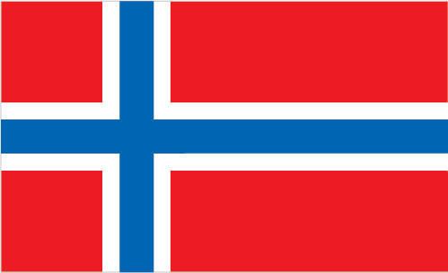  Children’s parade consists of marching waving home made flags in celebration of Norway’s independence. | Free, Civil Liberties score 1  CPI Score 87/100  Control of Corruption 97%  Percentile  Humans rights problems include violence against women and children as a perpetuating societal issue.  Government rejected asylum seekers to unfamiliar parts of their homelands. Governments investigated officials who committed violations, especially in security forces. | $68,400 per capita  80.8 Expectancy years  Male 9.1%,  Female 6.6%  12.2 births/1,000/pop.  8.1 deaths/1,000/pop.  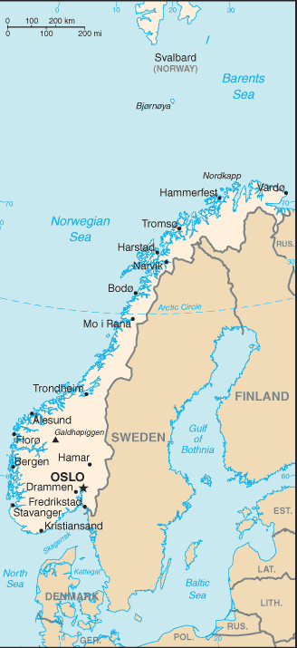  Stable economy with vibrant private sector, large state sector, and an extensive social safety net. Contributes sizably to EU budget | Political Rights 1  Mixed legal system of civil, common, and customary law; Supreme Court can advise on legislative acts.  Confederation of Norwegian Enterprise (Naeringslivets Hovedorganisasion) or NHO [President Tore ULSTEIN; CEO Kristin SKOGEN LUND]  Environmental groups; media; digital privacy movements.  Range of political parties open freely. Political Process has its own legislature.
Peru  Western South America, borders Childe, Ecuador, Bolivia, Columbia, Brazil and Pacific Ocean.  Capital – Lima  Climate – Varies from tropical, temperate to frigid in Andes  Area 1,285,216 sq. km,  World rank 20  Pop. 30,741,062  World rank 44  Government: Multiparty  Presidential system  UN, APEC, ICC, ITUC, WFTU, EITI, WHO, WTO | $389.1 billion, rank 48 Country of immigration in 19th and 20th centuries.  Has become country of emigration in recent decades. Two million Peruvians have emigrated in the last decade, principally to US, Spain, and Argentina.  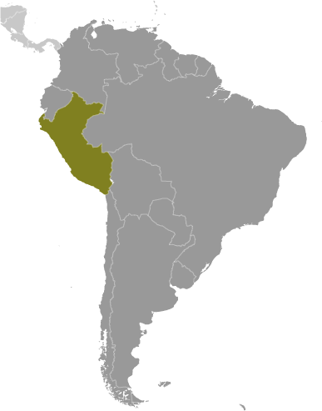 | 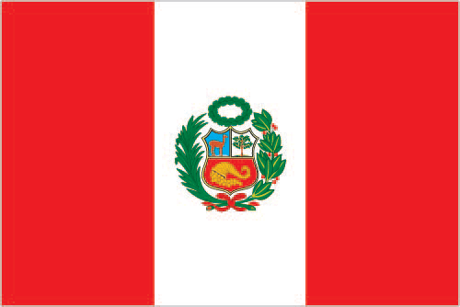  Three vertical bands of red, (hoist side), white, and red with coat of arms centered in white band; coat of arms features shield protecting vicuna (representing fauna), cinchona tree ( source of quinine, signifying flora, and yellow cornucopia spilling out coins (denoting mineral wealth).  Known as ‘Fiestas Patrias’, Peru marks its declaration of independence from Spain. | Free, Civil Liberties  Score 3  CPI Score 33/100  Control of Corruption 50%  Percentile  Most human rights problems include violence against women and children, trafficking in persons, corruption and impunity that undermined rule of law.  Government took steps to investigate, prosecuted or punished public officials accused of abuses. Officials sometimes engaged in corrupt practices with impunity. | $12,2000 per capita  73.54 Expectancy years  Male 97.3%,  Female 91.7%  18 births/1,000/pop.  6 deaths/1,000/pop.  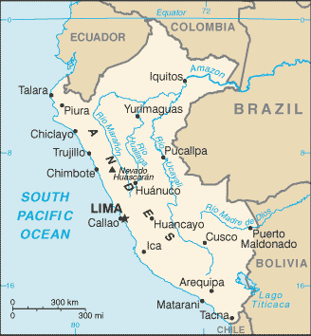  Peru’s urban and coastal communities have benefited from recent economic growth than rural. Poverty rate has dropped substantially during the last decade but remains high at about 30%. | Political Rights 2  Peruvian emigration began in 1980s due to economic crisis and violent internal conflict.  Overflows have stabilized in last few years as economic conditions improved.  Populations of Chines and Japanese descent are economically and culturally influential.  Competitive Peruvian parties highly fragmented and personalized.  Roman Catholic 81.3%  Evangelical 12.5%,  other 3.3%,  none 2.9% (2007 est.)

Dominican Republic
BBC News, Country Profile, Dominican Republic, Sept. 1, 2016 http://www.bbc.com/news/world-latin-america-19246340 (Nov. 16, 2016)
CIA, World Factbook, Dominican Republic, Nov. 3, 2016 https://www.cia.gov/library/publications/the-world-factbook/geos/dr.html (Nov. 16, 2016)
Freedom House, Freedom in the World 2016, Dominican Republic https://freedomhouse.org/report/freedom-world/2016/dominican-republic
(Nov. 16, 2016)
Transparency International, What We Do, Corruption by Country, Dominican Republic, 2016 http://www.transparency.org/country#DOM
(Nov. 16, 2016)
U.S. Dept. of State, Country Reports on Human Rights Practices for 2015, Dominican Republic http://www.state.gov/j/drl/rls/hrrpt/humanrightsreport/index.htm?year=2015&dlid=253009#wrapper (Nov. 16, 2016)

Libya
BBC News, Country Profile, Libya, Aug. 10, 2016 http://www.bbc.com/news/world-africa-13754897 (Nov. 16, 2016)
CIA, World Factbook, Libya, Nov. 3, 2016 https://www.cia.gov/library/publications/the-world-factbook/geos/ly.html (Nov. 16, 2016)
Freedom House, Freedom in the World 2016, Libya https://freedomhouse.org/report/freedom-world/2016/Libya (Nov. 16, 2016)
Transparency International, What We Do, Corruption by Country, Libya, 2016 https://www.transparency.org/country#LBY (Nov. 16, 2016)
U.S. Dept. of State, Country Reports on Human Rights Practices for 2015, Libya http://www.state.gov/j/drl/rls/hrrpt/humanrightsreport/index.htm?year=2015&dlid=252937#wrapper (Nov. 16, 2016)

Norway
BBC News, Country Profile, Norway, Feb. 25, 2016 http://www.bbc.com/news/world-europe-17743896 (Nov. 16, 2016)
CIA, World Factbook, Norway, Nov. 3, 2016 https://www.cia.gov/library/publications/the-world-factbook/geos/no.html (Nov. 16, 2016)
Freedom House, Freedom in the World 2016, Norway https://freedomhouse.org/report/freedom-world/2016/norway (Nov. 16, 2016)
Transparency International, What We Do, Corruption by Country, Norway, 2016 https://www.transparency.org/country#NOR (Nov. 16, 2016)
U.S. Dept. of State, Country Reports on Human Rights Practices for 2015, Norway
http://www.state.gov/j/drl/rls/hrrpt/humanrightsreport/index.htm?year=2015&dlid=252885#wrapper (Nov. 16, 2016)

Peru
BBC News, Country Profile, Peru, July 28, 2016 http://www.bbc.com/news/world-latin-america-19928905 (Nov. 16, 2016)
CIA, World Factbook, Peru, Nov. 3, 2016 https://www.cia.gov/library/publications/the-world-factbook/geos/pe.html (Nov. 16, 2016)
Freedom House, Freedom in the World 2016, Peru https://freedomhouse.org/report/freedom-world/2016/peru (Nov. 16, 2016)
Transparency International, What We Do, Corruption by Country, Peru, 2016 https://www.transparency.org/country#PER (Nov. 16, 2016)
U.S. Dept. of State, Country Reports on Human Rights Practices for 2015, Peru
http://www.state.gov/j/drl/rls/hrrpt/humanrightsreport/index.htm?year=2015&dlid=253035#wrapper (Nov. 16, 2016)

